**Logo** (see jpeg file attached):

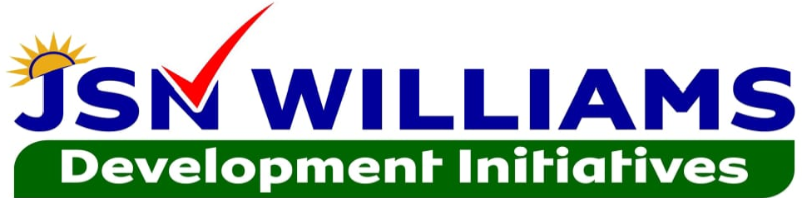

**Photo** (see jpeg file attached)

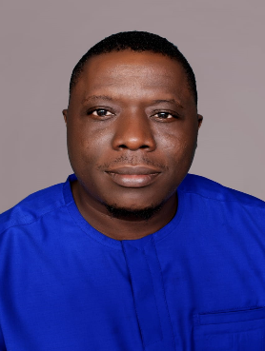**Bio information:**

Hon. Johnson Samuel Nagbe Williams, Sr. is a true son of the River Gee County. He was born onto the union of Mr. John Nyepah Williams, Sr. and Mrs. Sarah Tweh-ayeneh Howard-Salbie, on February 18, 1978, Washington Hill, in the Township of Nyaake, Webbo Statutory District, River Gee County. Hon. Williams is commonly known as I’Wash amongst his childhood friends, and has withstood the test of time as a typical Liberian child; engaged in farming at early age and took care of his grandparents. Hon. Williams lived with his grandparents, up to age 19, when the civil war displaced the entire southeastern Liberia in 1994 for which he sought refuge in the Ivorian village of Tiboto, where he continued his primary education. It was during these times of hardship, challenges, and difficulties when he had the opportunity to meet, see and interact with his kinsmen as a refugee boy. Hon. Williams is a devoted Christian, Roman Catholic by faith: baptized, confirmed and married and blessed with five children and currently resides in one of his own properties.

**Education:** Hon. Williams began his primary education at the Margrette Gibson Kindergarten School in 1982, where he spent one year, completing both Premier 1 & 2. Due to hard-work and dedication, he enrolled at the Nyaake Community School where he studied until 1989 when the civil war forced the school to closure. He continued his secondary schooling in 1992 in the Frontline Education System, which was run and managed by ADRA-UNHCR in Cote d’Ivoire, and graduated from Cape Palmas High School in 1999 with honors. Hon. Williams enrolled at Stella Maris Polytechnic in 2007 where he received his Associate of Arts Degree in 2010 and his Bachelor of Business Administration (BBA) Degree in Management in 2012, all with high academic honors. Additionally, he holds several certificates and diplomas in Gender Mainstreaming and Gender Budgeting, MTEF Budgeting, Agriculture, Public Policy & Economic Analysis, Project Management, Supply Chain & Stock Management, Conflict Resolution & Mediation, and Climate Change & Global Warming.

**Leadership and Professional Experience:** Hon. Williams has served in several positions in the Catholic Church, rendering voluntary services in youth activities, parish councils and his fraternity as well as on several committees. Hon. Williams is a former President of the Catholic Young Adults Association at the Holy Innocents Catholic Church located in New Matadi, Sinkor, Monrovia, Liberia. Hon. Williams became a member of the National Student Christian Council (NSCC), *the Student Christian Movement of Liberia (SCM Liberia)* in 2006 in Cape Palmas, and was appointed Deputy Regional Coordinator for Southeastern Liberia. Hon. Williams was later elected National Secretary-General of SCM Liberia where he managed and coordinated the National Secretariat from 2013-2015. In 2014, he was elected by the World Student Christian Federation to represent Liberia at the 35th General Assembly held in Bogota, Colombia. Hon. Williams is the Founder and First President of the River Gee University Student Association at Stella Maris Polytechnic. He is a founding member of the River Gee University Student Union – a platform that provides the space for students and youth to have constructive dialogues with policymakers and local authorities of the County. Hon. Williams is credited for organizing and hosting the First General Assembly of the River Gee University Student Union at the Stella Maris Polytechnic main Campus on Capitol Hill. Hon. Williams has worked for the Catholic Church of the Diocese of Cape Palmas from 2001-2007, serving in several positions before becoming Head of Caritas Field Office for River Gee County. While serving in this role, he managed several socio-economic development projects in the agriculture, health, WASH, social welfare development and education sectors worth more than US$350,000. Beneficiaries of these services included: Webbo, Tuobo, Sarbo, Potupo, Gbaepo, and Chedepo Districts. In January 2012, Hon. Williams was admitted through a national competitive process as the first River Gee Citizen into the President’s Young Professionals Program (PYPP), a flagship programme of former President Ellen Johnson Sirleaf aimed at recruiting the next general of civil servants, and placed at the Department of Budget, Ministry of Finance as Budget Analyst, a position which he occupied until he was promoted to the highest level in the Civil Service as Director for Budget Policy and Coordination. His roles as Director for Budget Policy were to develop fiscal frameworks and coordinate the processes for the formulation of the National Budget of the Government of Liberia. Throughout his tenure, has overseen the development and production of nine national budgets and several pieces of the fiscal policy instruments and reports.

**Contributions to the District and County:** Hon. Williams leadership capabilities and project management skills brought reliefs to thousands of River Gee citizens and other residents in the county when he was Head of Caritas Field Office from 2006-2007; his influence brought about the renovation of the Gbaweleken Market in Tuobo, construction of hand pumps in Sarbo, construction of shelters in Fish Town, Pronoken, Jarkaken, etc., distribution of thousands of households materials, agricultural inputs and tools for farmers, including female farmers, etc. across the district. Hon. Williams supported RIGUSU student representatives at the 2015 County Development Sittings held in Webbo Statutory District which result into the allocation of more than US$40,000 in scholarships and financial aid covering all public and private universities and colleges in the Country. Additionally, the holding of the first General Assembly of the River Gee University Student Union raised thousands of United States Dollars in scholarship grants from NOCAL and other donors which helped many struggling River Gee citizens studying at the various universities and colleges. Hon. Williams continues to support several River Gee citizens at various public and private schools as well as universities and colleges across the Country. Hon. Williams has made immense contributions towards community development projects including education (provided assorted cartons of MOE prescribed textbooks senior secondary school in Webbo and assisted the reopening of a pre-primary school in Kaibo-Worté since 1964 with MOE prescribed textbooks and initial stipend for volunteer teachers; provided 100 classroom desks for the public school in Glarro U-Bor; contributed L$100,000 towards to the rehabilitation of the Nyenebo Kabuken Elementary School), health (provided chemicals that prevented the collapse of the Jimmyville Clinic in Webbo and medical supplies), roads infrastructure (provided substantial financial contributions for roadside brushing, roads maintenance and bridge construction in Nyenebo, Gyetu and Glarro) and water and sanitation (provided financial contributions for rehabilitation of several water wells and pumps in the District. Other contributions include support to community radio stations and religious institutions. Hon. Williams has supported and continues to support peace and reconciliation efforts in the Deabo Chiefdom and the entire District #3 at large.

**Campaign manifesto**

With legislative powers, constructive advocacies and lobbyistic skills, Hon. Williams promises to address the following:

* **Education**: advocate and lobby for increased budgetary allocations, improvements in educational infrastructure and services, including establishment of a community college, increase the number of qualified classroom teachers, provision of housing facilities
* **Health**: advocate and lobby for increased budgetary allocations, improvements in basic healthcare service delivery, increase the number of qualified health and medical practitioners, provision of housing facilities
* **Agriculture**: advocate and lobby for increased budgetary allocations and donor support improvements in agricultural extension services –training, access to finance, access to markets, access to improved technologies, storage facilities, etc.
* **Roads Connectivity:** advocate and lobby for increased budgetary allocations and donor support for farm-to-market roads and border roads.
* Establish **Women** and **Youth** empowerment initiatives.

**About Us**

Where do we want to go?

Who are we?

What we do?

How do we get there?

**Contact Us**

Office of the Representative

Electoral District #3, River Gee County

Honorable House of Representatives

1st Floor, Room B1-20, Central Building

P.O. Box 9005, Capitol Hill, 1000 Monrovia, 10 Liberia

Central Office Lines:

+231 (77) 662 7707 | (88) 859 5869

District Office Line:

+231 (88) 731 7577

Working Hours: Mondays – Fridays, 0900 Hrs. to 1600 Hrs.

Visiting Hours: Fridays, 0900 Hrs to 1200 Hrs.

Web address: [www.jsnw.org](http://www.jsnw.org)

Email address: [info@jsnw.org](mailto:info@jsnw.org)

**Copyright inscriptions:**

Copyright 2024 JSN Williams Development Initiative. All rights reserved. The*JSN Williams Development Initiative is not responsible for the content of external sites.*